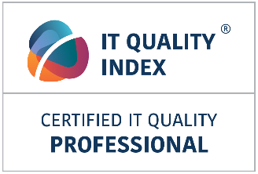
Registration form

Course | IT QUALITY INDEX Foundation  Target group: Candidates aiming to become Certified IT Quality Professional - CITQP
Pre-requisite | No prerequisite; recommended ITIL® Foundation or higher
Date and place | Date, place …….
Important information | After passing successful examination all candidates will be granted title and certificate:  Certified IT Quality Professional - CITQP
Price | Price: 495 EUR 396 GBP 594 USD (VAT excl.)
Promo code
Name of participant | Name  Phone  Email
Company name
Billing address
Contact person name
Contact person phone
Contact person email
VAT number
Order number:

Terms and conditions

- No pre-requirements apply, ITIL Foundation or higher certificate recommended.
- VAT will be added to course price according to accounting rules.
- Snack, drink, lunch included in course price.
- Printed course documentation will be provided to clients.
- Every participant passing course exam will receive certificate Certified IT Quality Professional - CITQP
- Payments for the course should be done within 30 days after passing the course upon invoice submitted by course organizer.
- The course can be rescheduled latest 7 days before the course date. Registered candidates will be contacted and provided with alternative dates of training.
- Mail this registration form to mailto:accreditation@itqualityindex.com?subject=CITQP

By submitting your application, you consent to the processing of the personal data specified in the application
form within the meaning of Regulation 679/2016 on the Protection of General Data Protection Regulation (GDPR).
These personal data must be processed for the purposes of organizing the course and for communication
with the participants.
The data will be processed by the administrator to withdraw consent by sending an e-mail to info@q4it.eu.

